

NUREG/CR-

ORNL/TM-2013/16

Office of Nuclear Regulatory Research

**Radiological Toolbox User’s Guide**

|  |  |
| --- | --- |
| **AVAILABILITY OF REFERENCE MATERIALS**  **IN NRC PUBLICATIONS** | |
| **NRC Reference Material**  As of November 1999, you may electronically access NUREG-series publications and other NRC records at NRC’s Public Electronic Reading Room at [http://www.nrc.gov/reading-rm.html.](http://www.nrc.gov.reading-rm.html.) Publicly released records include, to name a few, NUREG-series publications; *Federal Register* notices; applicant, licensee, and vendor documents and correspondence; NRC correspondence and internal memoranda; bulletins and information notices; inspection and investigative reports; licensee event reports; and Commission papers and their attachments.  NRC publications in the NUREG series, NRC regulations, and *Title 10, Energy*, in the Code of *Federal Regulations* may also be purchased from one  of these two sources:  1. The Superintendent of Documents  U.S. Government Printing Office  P.O. Box SSOP  Washington, DC 20402–0001  Internet: bookstore.gpo.gov  Telephone: 202–512–1800  Fax: 202-512-2250  2. The National Technical Information Service Springfield, VA 22161–0002  www.ntis.gov  1–800–553–6847 or, locally, 703–605–6000  A single copy of each NRC draft report for comment is available free, to the extent of supply, upon written request as follows:  Address: Office of the Chief Information Officer,  Reproduction and Distribution  Services Section  U.S. Nuclear Regulatory Commission  Washington, DC 20555–0001  E-mail: DISTRIBUTION@nrc.gov  Facsimile: 301–415–2289  Some publications in the NUREG series that are  posted at NRC’s Web site address http://www.nrc.gov/reading-rm/doc-collections/nuregs are updated periodically and may differ from the last printed version. Although references to material found on a Web site bear the date the material was accessed, the material available on the date cited may subsequently be removed from the site. | **Non-NRC Reference Material**  Documents available from public and special technical libraries include all open literature items, such as books, journal articles, and transactions, *Federal Register* notices, Federal and State legislation, and congressional reports. Such documents as theses, dissertations, foreign reports and translations, and  non-NRC conference proceedings may be purchased from their sponsoring organization.  Copies of industry codes and standards used in a substantive manner in the NRC regulatory process are maintained at—  The NRC Technical Library  Two White Flint North  11545 Rockville Pike  Rockville, MD 20852–2738  These standards are available in the library for reference use by the public. Codes and standards are usually copyrighted and may be purchased from the originating organization or, if they are American National Standards, from—  American National Standards Institute  11 West 42nd Street  New York, NY 10036–8002  www.ansi.org  212–642–4900  Legally binding regulatory requirements are stated only in laws; NRC regulations; licenses, including technical specifications; or orders, not in NUREG-series publications. The views expressed in contractor-prepared publications in this series are not necessarily those of the NRC.  The NUREG series comprises (1) technical and administrative reports and books prepared by the staff (NUREG/XXXX) or agency contractors (NUREG/CR-XXXX), (2) proceedings of conferences (NUREG/CP-XXXX), (3) reports resulting from international agreements (NUREG/IA-XXXX), (4) brochures (NUREG/BR-XXXX), and (5) compilations of legal decisions and orders of the Commission and Atomic and Safety Licensing Boards and of Directors' decisions under Section 2.206 of NRC's regulations (NUREG-0750). |
|  | |
| **DISCLAIMER**: This report was prepared as an account of work sponsored by an agency of the U.S. Government. Neither the U.S. Government nor any agency thereof, nor any employee, makes any warranty, expressed or implied, or assumes any legal liability or responsibility for any third party's use, or the results of such use, of any information, apparatus, product, or process disclosed in this publication, or represents that its use by such third party would not infringe privately owned rights. | |



**Radiological Toolbox User’s Guide**

Manuscript Completed: April 2013

Date Published:

Prepared by

K. F. Eckerman and A. L. Sjoreen

Oak Ridge National Laboratory

Managed by UT-Battelle, LLC

Oak Ridge, TN 37831-6170

C. Sun, NRC Project Manager

**Prepared for**

**Division of Systems Analysis**

**Office of Nuclear Regulatory Research**

**U.S. Nuclear Regulatory Commission**

**Washington, DC 20555-0001**

**NRC Job Code V6088**

ABSTRACT

The Radiological Toolbox software developed by Oak Ridge National Laboratory (ORNL) for U. S. Nuclear Regulatory Commission (NRC) is designed to provide electronic access to the vast and varied data that underlies the field of radiation protection. These data represent physical, chemical, anatomical, physiological, and mathematical parameters detailed in various handbooks which a health physicist might consult while in his office. The initial motivation for the software was to serve the needs of the health physicist away from his office and without access to his handbooks; e.g., NRC inspectors. The earlier releases of the software were widely used and accepted around the world by not only practicing health physicist but also those within educational programs.

This release updates the software to accommodate changes in Windows operating systems and, in some aspects, radiation protection. This release has been tested on Windows 7 and 8 and on 32- and 64-bit machines. The nuclear decay data has been updated and thermal neutron capture cross sections and cancer risk coefficients have been included. This document and the software’s user’s guide provide further details and documentation of the information captured within the Radiological Toolbox.

FOREWORD

The purpose of this document is to serve as a guide to the Radiological Toolbox software. The Radiological Toolbox was developed by ORNL for NRC as a means to provide quick access to databases needed in radiation protection, shielding, and dosimetry calculations.

The Radiological Toolbox is essentially an electronic handbook with limited computational capabilities beyond those of unit conversion. The Toolbox contains radioactive decay data, biokinetic data, internal and external dose coefficients, radiation interaction coefficients for elements and materials, photon and neutron, kerma coefficients, and other tabular data of interest to the health physicist, radiological engineer, and others working in fields involving radiation. The Toolbox includes a means to export the tabular data to a Microsoft Excel worksheet for use in further calculations. It operates in almost all Windows environments. Adobe Acrobat Reader, however, must be installed to display embedded *pdf* files.

CONTENTS

**Page**

ABSTRACT iii

FOREWORD v

CONTENTS vii

LIST OF FIGURES ix

LIST OF TABLES xi

ACKNOWLEDGMENTS xiii

ACRONYMS xv

1. INTRODUCTION 1

1.1 Release Notes 2

1.1.1 Installing the Software Installation 2

1.1.2 Known Bugs in Version 2.5 3

1.2 Support 3

2. TOOLBOX CONTENT 5

2.1 Main Menu Bar 5

2.2 Biological Data 5

2.3 Decay Data 6

2.4 Dose Coefficients 9

2.5 Dose Calculations 10

2.6 Early Inhalation 11

2.7 Risk Coefficients 12

2.8 Element Data 13

2.9 Material Data 15

2.10 Public Exposure Data 16

2.11 Radiation Field Data 17

2.12 Supplemental Data 18

3. HOW TO ACCESS RAD TOOLBOX FEATURES …... ……………………..…………………. 21

3.1 Use Of The Nuclide Input Grid In Requesting Dose Coefficients 21

3.2 Use Of The Choice Lists In Requesting Nuclide, Element, And Material Data 21

3.3 How to Export Data 21

3.4 Use The Activity Feature In Dose Calculations For A Decay Chain 21

3.5 How to Define a Material and Calculate its Interaction Coefficients 23

3.6 How to Generate Histogram Representation of Beta Spectra 23

3.7 How to Check the Integrity of the Rad Toolbox Data Files 26

4. SUMMARY 27

4.1 Summary and Conclusions 27

4.2 Topics for Further Consideration 27

5. REFERENCES 29

APPENDIX A 1IDENTITY OF ISOMERS IN ICRP PUBLICATION 38 A.1

LIST OF FIGURES

**Page**

Figure 1.1. Radiological Toolbox initial screen. 2

Figure 2.1. The initial screen for biological data. 6

Figure 2.2. The initial screen for decay data. 8

Figure 2.3. An example graphic of the Ac-223 decay chain. 9

Figure 2.4. The initial screen for dose coefficient data. 10

Figure 2.5. The initial screen for calculation of dose. 11

Figure 2.6. The initial screen for absorbed dose coefficients for early effects. 12

Figure 2.7. Federal Guidance Report 13 risk coefficients. 13

Figure 2.8. The initial screen for element data collection. 14

Figure 2.9. An example of a data table for actinium (Ac). 14

Figure 2.10. An example data plot. 15

Figure 2.11. The initial screen for material data. 16

Figure 2.12. The initial screen for public exposure data. 17

Figure 2.13. The initial screen for conversion coefficients for radiation fields. 18

Figure 2.14. The initial screen for supplemental data. 19

Figure 3.1. Activity and integrated activity at day 7 for Ra-226 chain. 22

Figure 3.2. The dose rate at day 7 post a deposition of 1 Bq/m2 of pure Ra-226. 22

Figure 3.3. Input screen for user-defined material. 23

Figure 3.4. Graphic display of the P-32 beta spectrum. 24

Figure 3.5. BINBETA module to represent the beta spectra in terms of a histogram. 25

Figure 3.6. Output file of the BINBETA module with the histogram tabulations of the beta spectrum. 25

LIST OF TABLES

**Page**

Table 1.1 General Description of the Radiological Toolbox Data Elements 1

Table A.1 Identification of Isomers in Publication 38 A-1

ACKNOWLEDGMENTS

This document was written under contract with the U. S. Nuclear Regulatory Commission (NRC) Office of Nuclear Regulatory Research. The authors acknowledges NRC staff members Casper Sun, Sami Serbini, Harriett Karagiannis, Elijah Dickson, Mohammad Saba, Vered Schaffer, and Stephanie Bush-Goddard for their guidance and review of the software and this document. The authors are grateful for detailed review of this document by Michael Bellamy, Richard Leggett, and Pat Scofield, and final preparation of this document by Roxanne Raschke.

The authors acknowledge:

• The International Commission on Radiological Protection (ICRP) for granting permission to extract the inhalation and ingestion dose coefficients from “The ICRP Database of Dose Coefficients: Worker and Members of the Public” CD. In addition, the nuclear decay data of ICRP Publication 107, included here, were prepared for that publication by A. Endo of the Japan Atomic Energy Agency (JAEA) and K. Eckerman of Oak Ridge National Laboratory (ORNL).

• The U. S. Environmental Protection Agency (EPA) for sponsoring the development of the dose coefficients for external exposure and those for deterministic effects at ORNL during the preparation of Federal Guidance Reports 12 and 13.

• The National Institute of Science and Technology (NIST) for publishing data on the interaction of alpha, electron, and photon radiations, which were abstracted and used herein.

We also appreciate the efforts of our user community for reporting various issues and their patience as issues were addressed. Finally we acknowledge the excellent administrative support provided by Julie Stringfield and Lindsey Aloisi of ORNL's NRC Project Office; their guidance was always adept, professional, and warranted.

ACRONYMS

AMAD activity median aerodynamic diameter

ANSI American National Standards Institute

BEIR Biological Effects of Ionizing Radiation

CRC cyclic redundancy check

CFR Code of Federal Regulations

DOE U.S. Department of Energy

EPA U.S. Environmental Protection Agency

FGR Federal Guidance Report

GP geometric progression

IAEA International Atomic Energy Agency

ICRP International Commission on Radiological Protection

ICRU International Commission on Radiation Units and Measurements

INES International Nuclear and Radiological Event Scale

JAEA Japan Atomic Energy Agency

LET linear energy transfer

MFP mean free path

NCRP National Council on Radiological Protection and Measurements

NEA Nuclear Energy Agency

NIST U.S. National Institute of Standards and Technology

NRC U.S. Nuclear Regulatory Commission

OECD Organization for Economic Co-operation and Development

ORNL Oak Ridge National Laboratory

ORDOSE Oak Ridge Center for Biokinetic and Dosimetric Research

RBE relative biological effectiveness

RSICC Radiation Shielding Information Computational Center

SI International System of Units

# INTRODUCTION

The Radiological Toolbox software, hereafter referred to as the Rad Toolbox or simply Toolbox, was developed by Oak Ridge National Laboratory (ORNL) for the U.S. Nuclear Regulatory Commission (NRC). This computer application provides access to physical, chemical, anatomical, physiological, and mathematical data (and models) relevant to the protection of workers and the public from exposures to ionizing radiation. A graphical user interface enables viewing of the data and its extraction for use in computations. The data are stored in Microsoft Access databases or in flat ASCII files and, for the most part, the values are in SI units. The data can be displayed and extracted in user-specific units. Users of the Toolbox can retrieve data from eleven data collections (see Table 1.1).

Table 1.1. General Description of the Radiological Toolbox Data Elements

|  |  |
| --- | --- |
| **Data Collections** | **Description of Data Collection** |
| Biological Data | Biokinetic models, reference anatomical data, bioassay data, and summary information on radiation health effects |
| Decay Data | Detailed information on the radiations emitted by radionuclides and members of serial decay chains |
| Dose Coefficients | Internal dose coefficients for intakes of radionuclides by workers and members of the public and external dose coefficients for members of the public exposed to radionuclides external to the body |
| Dose Calculation | Calculation of dose for worker or member of the public exposed to a radionuclide mixture |
| Early Inhalation | Absorbed dose coefficient integrated over a user-specific time period following an inhalation intake |
| Element Data | Radiation interaction coefficients with elements for alpha, electron, photon, and neutron radiations |
| Material Data | Radiation interaction coefficients with materials for alpha, electron, photon, and neutron radiations |
| Public Exposure Data | Summary information on radiation exposures to natural background radiation and from medical exposure |
| Radiation Field Data | Organ doses for workers resulting from idealized photon and neutron radiation fields |
| Risk Coefficients | Nuclide-specific risk coefficients for public exposure |
| Supplemental Data | Collection of reference information ranging from SI units to numerical limits on the activity content of radionuclides in transport |

The computational procedures within the Toolbox enable calculation of absorbed dose coefficients for a user-specified time period post an acute inhalation intake as needed in assessing potential deterministic effects, the derivation of radiation interaction coefficients for materials based on their elemental composition, the activity of members of serial decay chain at user-specified times, and the committed equivalent and effective dose for a user-specified mixture of radionuclides. Information is also provided on the excretion and retention of selected radionuclides following inhalation intakes in the workplace. The software’s help files provide access to textual information on topics ranging from those of a general nature to the details of models describing the fate of radionuclides in the body. Portions of this report are included within the software as an online user guide.

## Release Notes

This is the third general release of the Radiological Toolbox. Some minor restructuring of the information content of the Toolbox was undertaken with inclusion of risk coefficients from Federal Guidance Report (FGR) 13 (EPA, 1999), data on thermal neutron cross sections, and other enhancements suggested by users. In addition, this version of the Toolbox (Ver. 3.0) and its help files will run under Windows Vista, 7, and 8 operating systems on 32- and 64-bit machines.

### Installing the Software Installation

The Toolbox is installed by running the distributed set-up module TB_SETUP.EXE, a standard Windows installation file.[1] The default folder (directory) for the installation is C:\Rad_Toolbox however the user can install the software in a folder of his choice. It is recommended that the software not be installed in C:\Program Files folder. During installation the system may report messages for which the ‘ignore’ option is the appropriate response. The installation will place on the desktop the Toolbox icon as a shortcut to invoke the software, provide an option to view a Readme.txt placed in the folder and execute a check on the installed data files (see Sect. 3.7 for details). Clicking on the shortcut results in the display of the Toolbox user interface (or menu) as shown in Fig. 1.1. The interface consists of a column of buttons on the left, which define different data collections, and the folders on the right, which detail the specific items within the highlighted collection. The software can be removed from the computer by clicking on the executable unins000.exe that resides in the Toolbox folder.

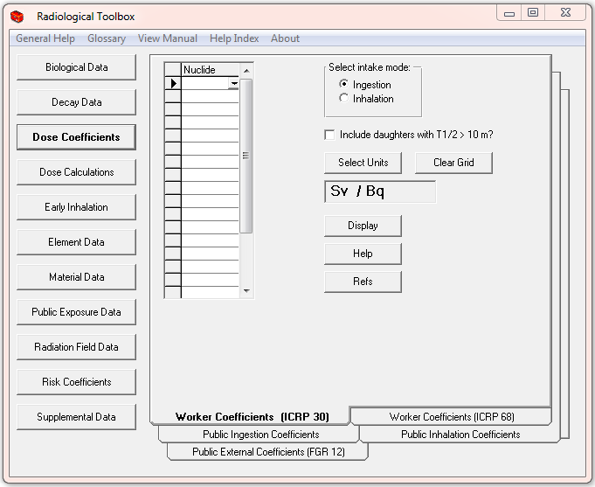

Fig. .. Rad Toolbox initial screen.

The Toolbox provides viewing of a number of documents with file extensions *pdf* and *txt*. This capability depends on the user having associated files with extensions *pdf* and *txt* with Adobe Acrobat Reader[2] and an ASCII editor (such as Microsoft’s Notepad), respectively. The export of user-selected data from the Toolbox is accomplished using Microsoft Excel, which must be installed to enable this functionality.

### Known Bugs in Version 2.5

In some instances, the graphical display of the decay chain associated with the parent radionuclide may contain artifacts, e.g., as in the Am-242m chain. However, the software should not crash as the chain is assembled. Caution: The decay chain graphics have not been tested for all potential parent nuclides.

Within the *Dose Coefficient* collection the identity of a requested nuclide is retained as one goes from one type of coefficient (folder) to the next. If coefficients of the requested type are not available for the specific nuclide, then a message box appears indicating that no information of the nuclide is available. This action can be demonstrated by pressing *Dose Coefficients*, selecting the *Public External Coefficient* folder, and requesting dose coefficients for the noble gas Kr-85. After displaying the coefficients, now change to the *Worker Coefficients (ICRP 30)* folder, note that the requested nuclide is still Kr-85, and now attempt to display coefficients for the ingestion mode of intake. Clicking *Display* results in a message box indicating *No nuclides found*. This occurs because dose coefficients for the intake of noble gas radionuclides are not addressed for internal irradiation (neither are radionuclides of half-life less than 10 min) but they are for external irradiation. Similar situations can occur within the *Element Data* and *Material Data* collections as interaction coefficients present for an element or material may not be present for all elements or materials.

## Support

Users encountering difficulties or potential errors are encouraged to contact NRC[3] for guidance and to have such issues addressed in future updates. Users are also encouraged to send suggestions for additional features and databases for inclusion in future updates to the Toolbox.

A discussion forum for Toolbox users is available at the ORNL Center for Radiation Protection Knowledge <https://ordose.ornl.gov/forum/>. This forum will enable users to exchange information and share their experiences with the Toolbox.

# TOOLBOX CONTENT

When the Toolbox is initiated, the screen of Fig. 1.1 appears. The discussion below, refers to the column of buttons on the left side of the screen as *data collections*, and the structure on the right as *folders*. Note these terms do not refer to database structures but are used to facilitate the discussion. The headings of Sect. 2.2 – 2.11 below correspond to the *data collections* of the Toolbox as indicated in Fig. 1.1.

## Main Menu Bar

The menu bar at the top of the screen (see Fig. 1.1) provides access to the software help files. Many of the *folders* include access to additional help files on specific data elements. The items on the main menu bar are:

* General Help– Introduction to Toolbox
* Glossary– General glossary of radiological terms
* View Manual – An abbreviated form of this report
* Help Index – Index of the Toolbox contents
* About – Toolbox version, acknowledgments, and button to check file integrity

## Biological Data

The *Biological Data* collection (Fig. 2.1) of the Toolbox contains data on the following:

* Biokinetic Models
* Bioassay Data
* Composition of Tissues
* Organ Masses –ICRP 23/89/72
* ICRP 89 Reference Values
* Radiation Health Effects

These data are displayed in tables many of which can be exported to Microsoft Excel. The biokinetic models are from ICRP Publications 68 (ICRP, 1994) and 72 (ICRP, 1996). Urinary and fecal excretion data and retention data in the bioassay data collection were calculated using DCAL (Eckerman *et al.,* 2006) for a limited set of radionuclides based on the models of Publication 68. The information on the compositions of tissues is from Coursey *et al.* (2001). The organ mass data are from Publications 23, 72, and 89 (ICRP, 1975, 1995, 2002). The latter is an extensive set of anatomical and physiological reference values. Information on health effects, both deterministic and stochastic, of ionizing radiation have been summarized from various sources (Evans *et al*., 1983; ICRP, 1990, 2005, 2007; EPA 1994, 2011; BEIR, 2006; IAEA, 1998, 2005; Scott, 2004; NCRP 2008, 2009; Rathbone, 2007; Gusev *et al.,* 2001).

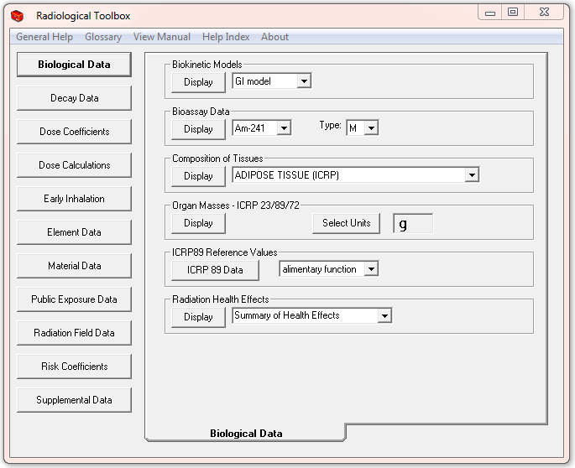

Fig. .. The initial screen for biological data.

## Decay Data

The *Decay Data* collection (Fig. 2.2) of the Toolbox provides detailed data on the energy and intensities of the radiations emitted during nuclear transformations (decays). The data are from ICRP Publication 107 (ICRP, 2008); an earlier version of the Toolbox included data from ICRP Publication 38 (ICRP, 1983) with a second set of data from published compilation (Endo *et al.,* 1999; Endo and Yamaguchi, 2001). The ICRP Publication 107 data are in the format of the file structure detailed in Publication 107. The updating of the Toolbox to ICRP Publication 107 ensures that these data reflect current knowledge. All nuclide specific data within the Toolbox conform to the nuclide identity of Publication 107. See Appendix A for additional details.

Information on the energy and intensity of the emitted radiations are displayed in separate tables for alpha particles, beta transitions (average energy), photons, and mono-energetic electrons. The type of radiation is identified in each table and its associated code, the variable *ICODE* – as defined in ICRP Publication 107, is displayed. The beta table contains information on both β+ and β– transitions; however, the plotted spectrum is the composite. X-rays, gamma rays, and annihilation quanta are included in the photon table with their assigned *ICODE*. The data for internal conversion and Auger electrons are included in the mono-energetic electron table. The caption of each table lists the number of radiations of the indicated type emitted in the decay processes.

The activity of the selected radionuclide (including its radioactive daughter products) can be calculated by selecting *Activity* as the data type, entering the time of interest, and pressing *Display*. The calculation assumes a unit activity of the radionuclide (the parent in the case of a chain) at time zero. The displayed results can then be scaled by a user-specified value. This feature is discussed further in Sect. 3.4.

All tables of energy-intensity data are sorted by increasing energy of the emitted radiation. The tables include all emitted radiations without regard to the potential significance. It is possible to specify a fractional energy cutoff in percent thus limiting the tables to those radiations that contribute more that the percentage cutoff to the total emitted energy. For example, a cutoff of 1% would result in the table containing only radiations contributing more than 1% to the total energy for that radiation type. It is possible to sort the data by increasing intensity (yield) or by energy (the default sort variable) by clicking on the column heading. Each table may be separately exported to Excel. (When the *Export* button is pressed only the displayed table is exported.)

The beta spectrum is displayed as a graph and exported as a tabulation of the number of electrons *Y(E)* emitted with energy between *E* and *E+dE* as a function of energy *E*. That is, as a differential energy spectrum. For further information see Sect. 3.6.

Provisions are provided to display the air kerma-rate constant, as defined by ICRU (1998), and the point source air-kerma coefficient for the radionuclides of the ICRP 107 collection.

The air kerma-rate constant as defined by ICRU is for an ideal point source of the radionuclide and is due only to photons emitted by the source in a vacuum. Annihilation photons, included in the tabulated emissions in the case of beta plus decay, are not emitted by the radionuclide but rather arise in the absorbing media and thus are not include in the air-kerma constant. The point source air-kerma coefficient is defined to include the contribution of annihilation photons and, in the case of spontaneous fission, that of neutrons. Shown below are the constant and coefficient for I-122, which decays by electron capture and beta plus decay. The two quantities are explained under the help button.

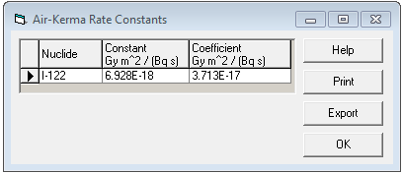

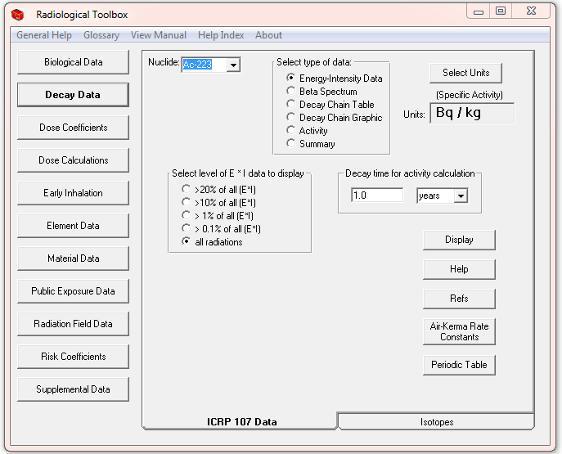

Fig. .. The initial screen for decay data.

The decay chain table includes the specific activity, half-life, decay mode, and identification of radioactive daughters with their branching fractions. The *Summary* display lists the various types of radiations (alpha, electrons, photons, etc.) emitted by the radionuclide including their average and total energy (MeV) per nuclear transformation (nt or Bq s) and the radionuclide’s specific activity (default units being Bq/kg).

The decay chain graphic includes half-lives of the chain members; see Fig. 2.3. The stable end product of the chain is included in the graphic but not in the decay chain table. The graphic cannot be exported.

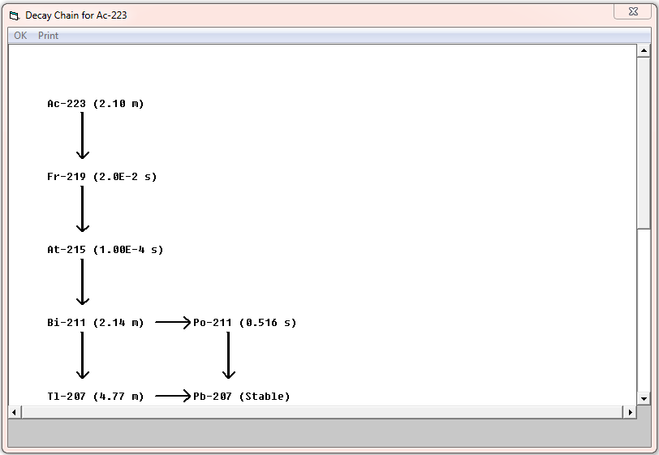

Fig. .. An example graphic of the Ac-223 decay chain.

## Dose Coefficients

The *Dose Coefficients* collection (Fig. 2.4) of the Toolbox provides access to five sets of nuclide-specific dose coefficients. These are: external dose rate coefficients for 826 radionuclides from Federal Guidance Report 12 (EPA 1993), the committed dose coefficients for inhalation and ingestion intakes of 738 radionuclides by workers in ICRP Publications 30 and 68 (ICRP, 1979, 1994; EPA, 1988), and age-dependent committed dose coefficients for the inhalation and ingestion intakes of 738 radionuclides[4] by members of the public (six ages at intake) in ICRP Publication 72 (ICRP, 1995). The coefficients are consistent with those of ICRP Publications 68 and 72 and were extracted, with permission, from the ICRP CD (ICRP, 2002)[5]. The coefficients of ICRP Publication 30 were available in data files at ORNL. For each coefficient set it is possible to display up to 20 nuclides at a time for a chosen route of exposure or intake. The displayed table can be exported to an Excel spreadsheet. The default units used are the SI units, i.e., the units of the original data. However, the user may specify non-SI units for display and export.

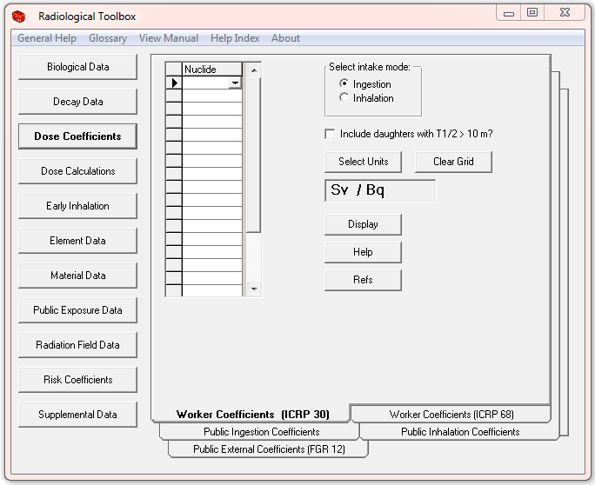

Fig. 2.4. The initial screen for dose coefficient data.

Coefficients are displayed for the organ equivalent dose and the effective dose for the selected radionuclide. For exposure to radionuclide contamination outside the body, the coefficients are for the adult as considered in Federal Guidance Report 12 (EPA, 1993). For inhalation intakes of radionuclides the dose coefficients are displayed for all particulate absorption types (or clearance class in the ICRP 30 data set) and for gases and vapors, if applicable. For ingestion intakes, the coefficients for all chemical forms, characterized by the *f*1 value defining the fractional absorption from gastrointestinal (GI) tract, are shown for the selected radionuclide. The absorption type or class, *f*1 value, and half-life are included in the display and in tables exported to Excel.

A note of caution: The set of nuclides selected for display and selected units of the coefficients ‘sticks’ across the folders (data sets) of the section. That is, once a set of nuclides or units has been specified, this request applies to all dose coefficients to be displayed until the user changes the request. If inhalation and ingestion coefficients are not available for a nuclide initially specified in the external coefficient folder a suitable message is displayed.

## Dose Calculations

The *Dose Calculations* collection (Fig. 2.5) was developed to enable rather simple numerical calculations of dose for a mixture of radionuclides. The user selects the folder with the appropriate dose coefficients and then identifies the nuclides and their activity. The mixture can consist of up to 20 radionuclides. In the case of external exposure the dose coefficients are uniquely identified by the route of exposure and the radionuclide. Thus it is possible to include the total dose for the mixture in the table. This is not the situation for the intake of radionuclide where multiple coefficients exist for a nuclide due to different chemical forms. Thus for inhalation and ingestion intakes it is not possible to include the total dose in the table but rather the table includes the dose for intake of each chemical form. The user should export the table to Excel, delete columns of irrelevant chemical forms, and derive the total dose within Excel.

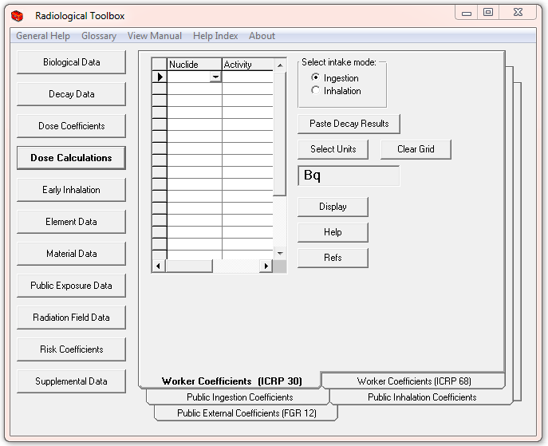

Fig. 2.5. The initial screen for calculation of dose.

The *Activity* feature of the *Decay Data* collection can be used to derive the activity (and time-integrated activity) of the members of a decay chain. That information can be imported to the *Dose Calculations* collection (see *Paste Decay Results* button) and the calculations for the chain displayed. This feature is discussed further in Sect. 3.4.

## Early Inhalation

The *Early Inhalation* collection (Fig. 2.6) of the Toolbox provides a means to derive inhalation dose coefficients for deterministic health effects. Absorbed dose is the relative dosimetric quantity and separate values are given for radiations of low and high linear energy transfer (LET). Appropriate values of the relative biological effectiveness (*RBE)*, see the suggested values (IAEA, 2005) under *Radiation Health Effects* in the *Biological Data* collection, can then be applied to the absorbed dose components. Coefficients for the small intestine, red marrow, lung (mass average), and alveolar interstitial region can be displayed. The coefficients are derived from dosimetric data for the adult archived on the Federal Guidance Report 13 CD (EPA, 2002). These data were based on an aerosol characterized by an activity median aerodynamic diameter (AMAD) of 1 µm. The user may specify integration times (up to 20 times) from 1 day to 10 years. The units of these absorbed dose coefficients may be changed and the values exported to Excel.

A complete set of age-specified absorbed dose coefficients for all organs/tissues and either inhalation or ingestion intakes is available within the Acute Dose Calculator software. This software is available from EPA (<http://www.epa.gov/radiation/federal/techdocs.html>).

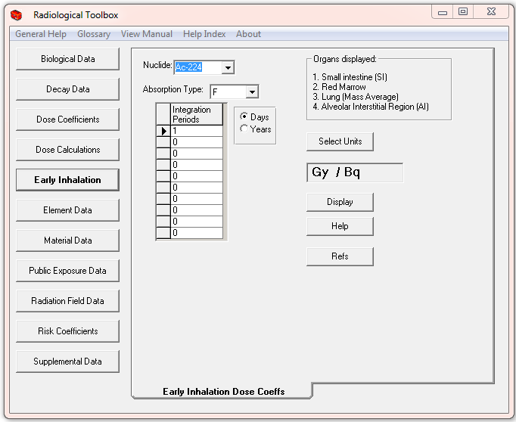

Fig. 2.6. The initial screen for absorbed dose coefficients for early effects.

## Risk Coefficients

The *Risk Coefficients* collection of the Toolbox provides access to the risk coefficients of Federal Guidance Report 13 (EPA, 1999, 2002) as shown in Fig. 2.7. The risk coefficients of that report apply to an average member of the US public in the sense that the estimated risk are averaged over the age and gender distribution of a hypothetical closed “stationary” population whose survival functions and cancer mortality rates are based on those of the US. The hypothetical population is referred to as “stationary” because the gender-specific birth rates and survival functions are assumed to remain invariant over time.

For a given radionuclide and exposure mode, both a mortality and morbidity risk coefficient are displayed. The mortality risk coefficient is an estimate of the risk to an average member of the US population, per unit activity inhaled or ingested for internal exposures or per unit time-integrated activity concentration in air or soil for external exposure, of dying from cancer as a result of the intake of the radionuclide or external exposure to its emitted radiations. The morbidity risk coefficient is a comparable estimate of the average total risk of experiencing a radiogenic cancer, whether or not the cancer is fatal. The data are presented for each of 14 cancer sites. For details regarding how the coefficients were derived, how to apply the coefficients, and their limitations the user should consult Federal Guidance Report 13 (EPA, 1999).

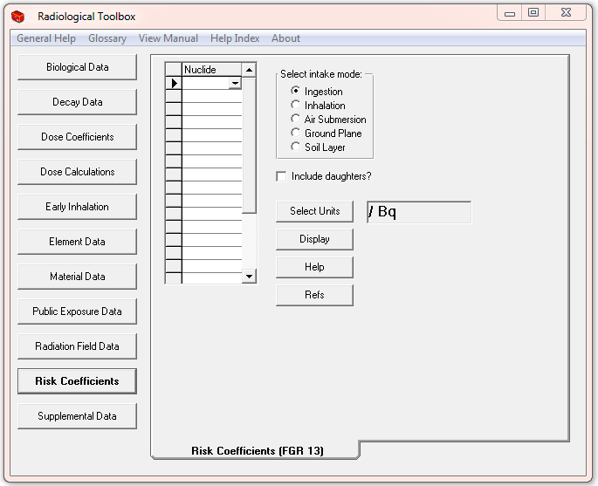

Fig. 2.7. Federal Guidance Report 13 risk coefficients.

## Element Data

The *Element Data* collection of the Toolbox provides access to interaction coefficients for alpha, electron, photon, and neutron radiations in passing through elemental absorbers (Fig. 2.8). The user may select the type of data (coefficient) for display and its units. Once the data table (Fig. 2.8) is displayed, the data may be plotted (Fig. 2.9) as a function of energy, by double clicking on the data column of interest. The entire table may be exported to Excel. Coefficients are not available for every element or for each radiation type. The photon cross section, alpha, and electron data are from Berger *et al.* (1999, 2005). The parameters of the geometric progression (GP) form of the photon build-up factor (Harina, 1983; Harima *et al*., 1986) are from ANSI Standard 6.4 (1991). The user can display the parameter values or a table of the buildup factors for photon of energy between 0.015 and 15 MeV at distances ranging from 0.5 to 60 mean free paths (MFP). The *Photon Buildup* folder contains a graphic of the equation for the GP build-up factor. The photon and neutron kerma coefficients were taken from KERMAL, RSICC package DLC-143 (Howerton, 1986a, 1986b).

The *Atomic Mass* folder of the *Element Data* collection provides access to atomic mass and isotopic abundance data. These data, which can be exported to Excel, are from Coursey *et al.* (2001). Stable, primordial, and cosmogenic radioactive isotopes are marked with a colored background. This information was abstracted from the 16th edition of the *Chart of the Nuclides* (Baum *et al.,* 2002).

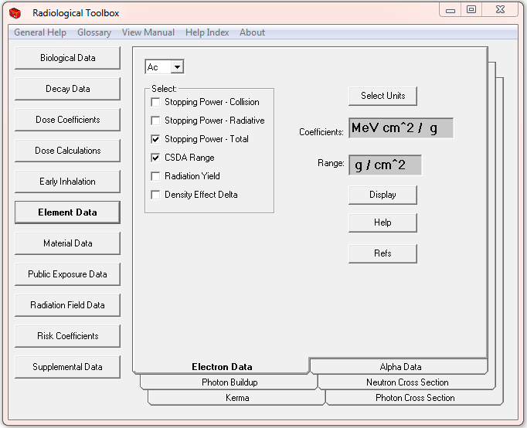

Fig. 2.8. The initial screen for element data collection.

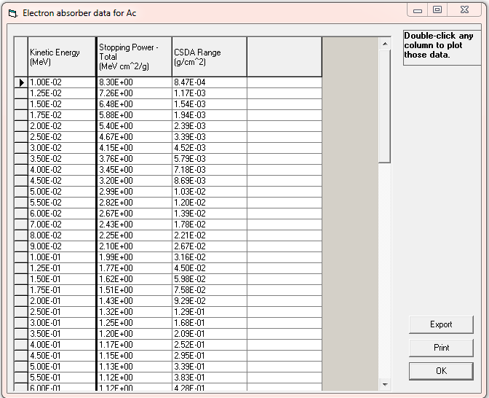

Fig. 2.9. An example of a data table for actinium (Ac).

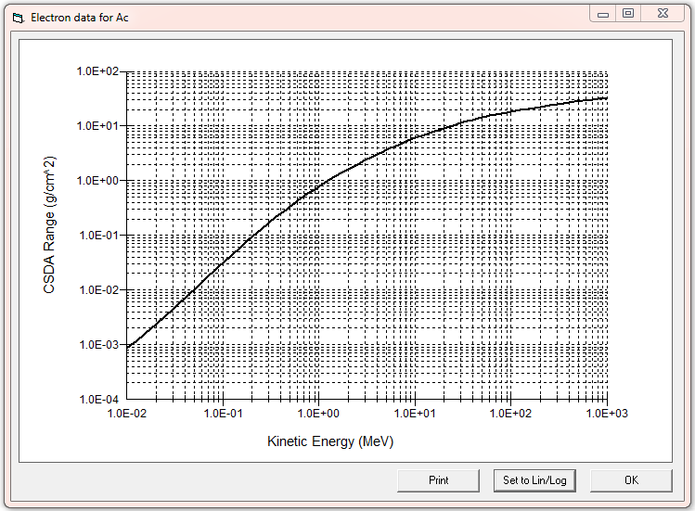

Fig. 2.10. An example data plot.

## Material Data

The *Material Data* collection (Fig. 2.11) provides access to various radiological properties of materials. Interaction and kerma coefficients for the materials (Berger *et al*., 2005) are derived using the elemental compositions specified by Coursey e*t al*. (2001) with reference to Coplen (2001), Rosman and Taylor (1998) and Audi and Wapstra (1995). Within the *Composition* folder the elemental composition and assume density of the material can be viewed and exported. In addition, the PNNL-15870 compendium of material compositions (Williams *et al*., 2006) tabulated for use in radiation transport modeling is available for viewing. The material definitions in the kerma references (Howerton, 1986a, 1986b) are not used. As kerma values were only available for element of atomic numbers less than 30, only materials composed of these elements can be considered. In computing the coefficients, the isotopes of the composition were assumed to be either the natural occurring isotope or the most abundant isotope of the element. The interaction and kerma coefficients can be exported to Excel spreadsheets.

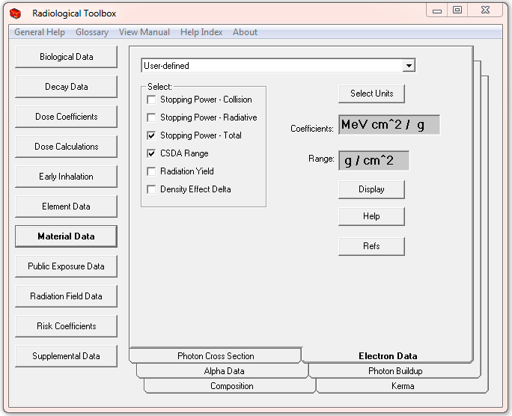

Fig. 2.11. The initial screen for material data.

Photon build-up factors (geometric progression GP form) are derived for materials following the procedure outlined by Sidhu *et al*. (1999, 2000). The procedure estimates the parameters of the GP form for the mixture using the parameters tabulated for the 23 elements specified in the ANSI standard (ANSI, 1964). The parameters of the GP form or a table of the build-up factors for photon of energy between 0.015 and 15 MeV at distance ranging from 0.5 to 60 mean-free paths (MFP) can be displayed and exported to Excel.

Provisions are included in this release to enable the user to define a material and calculate its interaction coefficients. See Sect. 3.5 for an illustration of this feature.

## Public Exposure Data

The *Public Exposure Data* collection (Fig. 2.12) contains data such as:

* Natural Background Radiation
* Background Radiation in the Body
* Radionuclides in Materials
* Radionuclides in Devices
* Primordial Radionuclides
* Typical Exposures during Medical Procedures

The annual dose from natural background radiation in the United States and radionuclides in the body are from Report 160 of the National Council on Radiation Protection and Measurement (NCRP, 2009). Information on radionuclides in material and the primordial radionuclides are from the Radiation Information Network (<http://www.physics.isu.edu/radinf/>). The information on radionuclides in devices is from a report of the International Atomic Energy Agency (IAEA, 2003). The typical exposures during medical procedures are from the DOE Dose Range Graphic (the graphic is included in the Toolbox – see *Supplemental Data* collection). The concentrations of radionuclides in materials are from Schneider *et al.* (2001). The typical exposures during medical procedures are from Mettler *et al.* (2010).

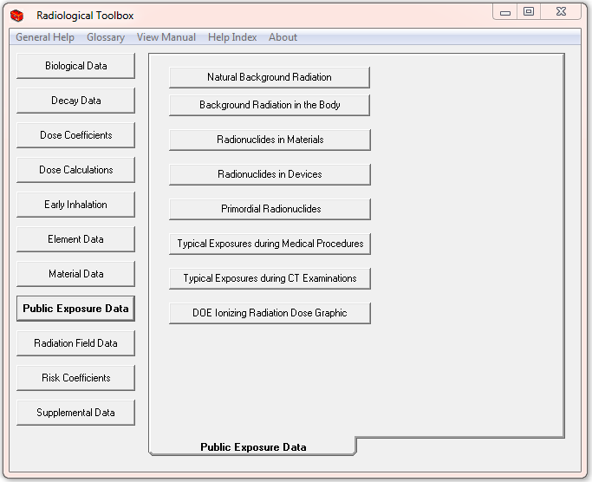

Fig. 2.12. The initial screen for public exposure data.

## Radiation Field Data

The *Radiation Field Data* collection (Fig. 2.13) provides access to conversion coefficients for the operational quantities and organ dose coefficients for mono-energetic neutron and photon radiation fields. These data, compiled by a joint task group of ICRP and ICRU, were abstracted from ICRP Publication 74 (ICRP, 1996). Organ dose coefficients are available for antero-posterier, postero-anterier, left-lateral, right-lateral, rotational, and isotropic exposure geometries. Graphics defining these geometries are displayed. Once a table of coefficients is displayed, the user may plot any data column by double-clicking on the column heading of the column. The entire table may be exported to Excel.

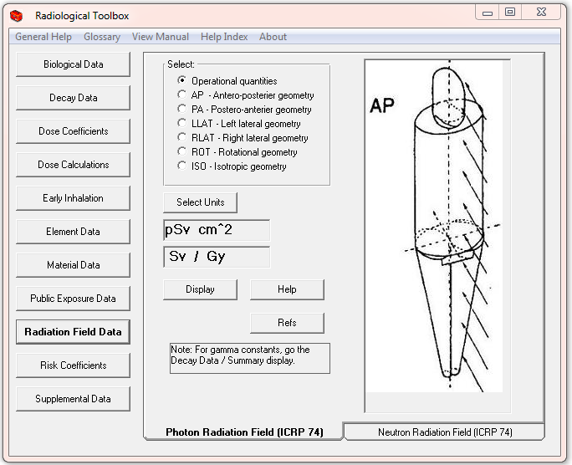

Fig. 2.13. The initial screen for conversion coefficients for radiation fields.

## Supplemental Data

The *Supplemental Data* collection (Fig. 2.14) provides access to other radiation and health physics data. This collection includes:

* SI Units
* Physical Constants
* Conversion Factors
* International Nuclear and Radiological Event Scale (INES)
* Formulas
* Web Pages
* DOE Dose Ranges
* Transport Package Regulations (A1/A2 Table)

The *Physical Constants* and *Conversion Factors* may be exported to the clipboard by right-clicking on the desired numerical value. A simple web browser is available to view the web links. The discussion of SI units is abstracted from Baum *et al.* (2002). An extensive listing of physical constants is available from NIST (<http://physics.nist.gov/constants>). The unit conversion factors are from Lide (1997). The formula or equations are from various sources. The *DOE Dose Ranges* graphic was compiled by the DOE Office of Science to provide an “orders of magnitude” sense of radiation doses range from NCRP’s “Negligible Dose” to those of cancer radiotherapy. The graphic can be viewed in either SI or conventional units.

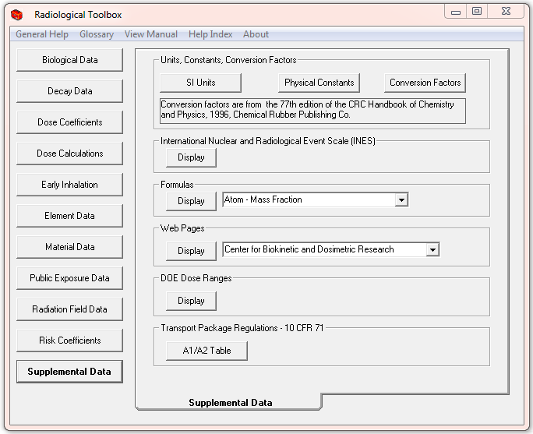

Fig. 2.14. The initial screen for supplemental data.

The INES tool for communicating the significance of nuclear and radiological events to the public in a consistent manner is provided. The IAEA coordinated the development of the scale with the OECD/NEA and the support of more than 60 member states. Further information and a user’s manual is available at <http://gnssn.iaea.org/regnet/Pages/INES.aspx>.

The transport package regulation consists of the *A*1 and *A*2 values for radionuclides from Appendix A of 10 CFR Part 71 (FR, 2004). The values are given in SI units, TBq (1012 Bq), and conventional units, Ci. The *A*1 value is the maximum activity of a special form of the radionuclide permitted in a Type *A* package. The *A*2 value is the maximum activity of a radionuclide, other than in a special form, that is permitted in a Type *A* package. A Type *A* package is defined as a package complying with DOE regulations in 49 CFR Part 173.

## 3. HOW TO ACCESS RAD TOOLBOX FEATURES

This section describes the use of some of the Rad Toolbox features.

## 3.1 Use Of The Nuclide Input Grid In Requesting Dose Coefficients

Dose coefficients can be requested for up to 20 radionuclides in a single query by either typing in the radionuclide name or select it from the choice list. The user can navigate the choice list by typing the first few characters of the selected name and then pressing *Enter*. If an invalid name (either misspelled or a radionuclide not in the database) is entered, an error message is displayed and that entry must be corrected or changed to a blank to continue. Always enter a name in the top cell of the list, but blank cells may exist between filled cells. The table displayed will not necessarily have the radionuclides in the order that they were entered.

## 3.2 Use Of The Choice Lists In Requesting Nuclide, Element, And Material Data

For choice lists where a single item is to be selected, either type in the item name or select it from the choice list. The user can navigate the choice list by typing the first few characters of the selected name. If an invalid name is provided (either from misspelling or specifying an item not included in that database) an error message is displayed and the entry must be corrected to continue.

## 3.3 How to Export Data

*The export of data from the Rad Toolbox is possible only if Microsoft Excel has been installed.*

An *Export* button is available on each table that may be exported. The first time the *Export* button is pressed, a new Excel file is opened. The data in the displayed table are copied to the first sheet of the Excel file. If the Excel file remains open then additional exported data tables will be copied to the same sheet as the previously exported data. The new data will be positioned next to the previous data, with one blank column in between. If the Excel file is closed then the next request to export a data table results in a new Excel file. The Rad Toolbox will not export data to an existing Excel file.

## 3.4 Use The Activity Feature In Dose Calculations For A Decay Chain

As an example, consider the calculation of the external dose rate one week post the deposition on the ground surface of pure Ra-226. The *Activity* feature of the *Decay Data* collection can be used to compute the activity and time-integrated activity (s) or nuclear transformation of each chain members over a user-specified time (d) period. Fig. 16 shows such values. The activity data is selected by clicking on its column heading and pressing the *Copy* button.

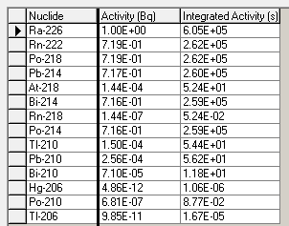

Fig. 3.15. Activity and integrated activity at day 7 for Ra-226 chain.

The user then goes to the *Dose Calculations* collection, selects the *Public External Coefficients* folder, presses the *Paste Decay Results* button, and selects *Ground Surface* as the exposure mode. Pressing *Display* provides a table of the contribution to dose of each chain member as seen in Fig. 3.2. Note the members of the chain may not be listed in the order of the decay chain. Note: To show the total column in Fig. 3.2, the display has been scrolled to the right. The values under the total column represent the dose rate (Sv/s) at day 7 post the initial deposition of 1 Bq/m2 of pure Ra-226. This table can be exported to Excel.

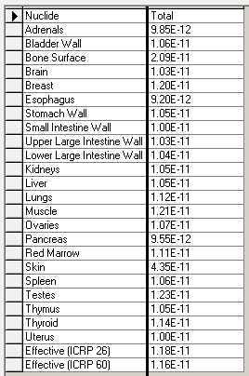

Fig. 3.16. The dose rate at day 7 post a deposition of 1 Bq/m2 of pure Ra-226.

Had the integrated activity (s) been pasted into the dose calculations the resultant numerical values would represent the dose (Sv) over the seven-day period following the initial deposition of 1 Bq/m2 of Ra-226. The display would indicated dose rate (Sv/s) not dose (Sv) - the user must be mindful of the nature of the calculations undertaken.

## 3.5 How to Define a Material and Calculate its Interaction Coefficients

As an example, consider a calculation of the electron interaction coefficients for the user-defined material *silly cement*. *Silly cement* consists of H, C, and Cl in mass fractions 0.06, 0.54, and 0.40, respectively. When the *Material Data* collection is displayed the pull-down menu of materials defaults to “User-defined.” Clicking the *Display* button brings up the input screen to define the material. The completed input screen for *silly cement* is shown in Fig. 3.3. Press the *Exit* button to compute and display the table of interaction coefficients for *silly cement*. The input screen includes a note that must be followed for proper closure of the data input.

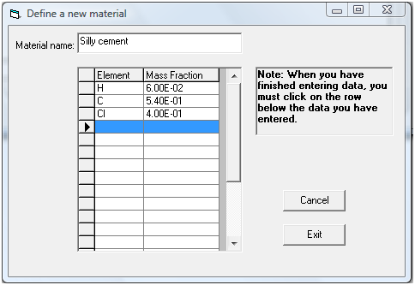

Fig. 3.17. Input screen for user-defined material.

## 3.6 How to Generate Histogram Representation of Beta Spectra

As discussed in Sect. 2.4, the Toolbox includes the beta spectra data of ICRP Publication 107 (ICRP 2008). The number of electrons emitted per nuclear transformation of energy between *E* and *E* + d*E* are tabulated on a fixed logarithmic-type energy grid extending out to the end-point energy. The P-32 beta spectrum is shown graphically in Fig. 3.4 as created by the Toolbox. Note the graphic label indicates the end point energy of the spectrum in this case is 1.7106 MeV with an average energy of 0.695 MeV.

The number of electrons per nuclear transformation *N* is given by

|  |  |
| --- | --- |
|  | (1) |

and the average energy

|  |  |
| --- | --- |
|  | (2) |

where *Y*(*E*) is the tabulated spectrum (export of those values is available for the graph) and the integrals of Eqs. (1) and (2) extent over the spectrum; the infinite upper limit is the end point energy.

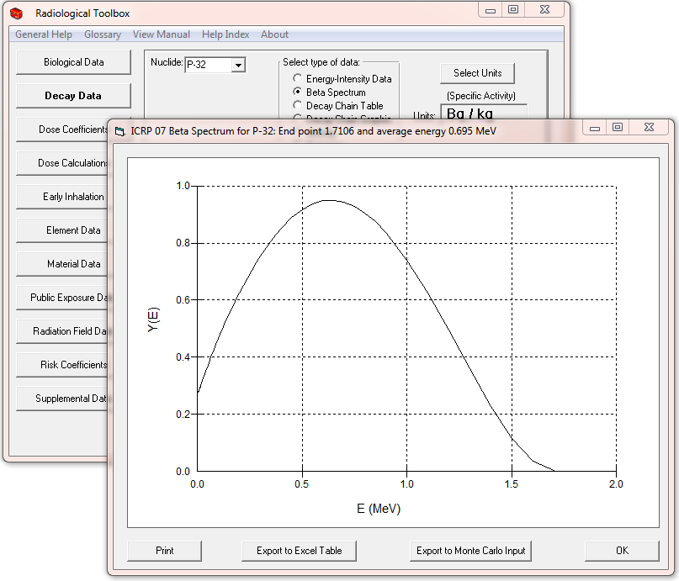

Fig. 3.18. Graphic display of the P-32 beta spectrum.

The graphical display includes provisions to print and export the spectrum and to invoke a module to represent the spectrum as a histogram that might be sampled in Monte Carlo simulations. Clicking the “Export to Monte Carlo Input” invokes the BINBETA module, which for a user-specified number of energy bins (default 10) tabulates histograms normalized to the emission of 1 beta particle (see Fig. 3.5). The output of the BINBETA module is shown in Fig. 3.6.

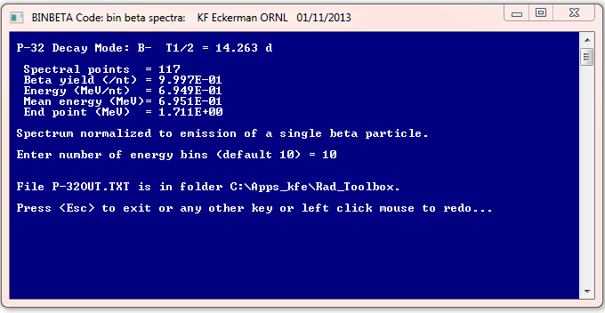

Fig. 3.19. BINBETA module to represent the beta spectra in terms of a histogram.

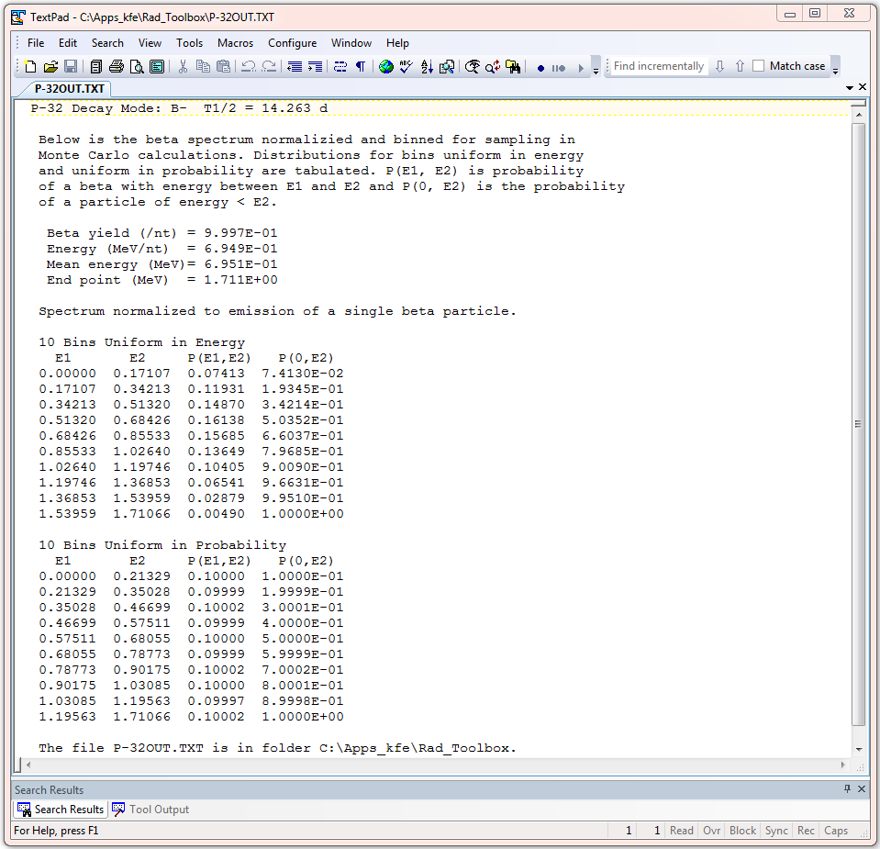

Fig. 3.20. Output file of the BINBETA module with the histogram tabulations of the beta spectrum.

## 3.7 How to Check the Integrity of the Rad Toolbox Data Files

Following installation of the Radiological Toolbox a procedure is invoked to confirm the integrity of data files by performing an cyclic redundancy check; a so-called CRC procedure. This error-detecting procedure is commonly used to detect accidental changes in data files. At any time the user can confirm the integrity of the data files by clicking on the CRC Check button on the “About” pull-down menu off the main menu.

# 4. SUMMARY

## 4.1 Summary and Conclusions

The objective of the Radiological Toolbox software is to provide the health physicist with electronic access to the extensive and varied data that underlie occupational and environmental radiation protection. These data are available within documents issued by various national and international authorities. Under the guidelines for software development, this application is categories to be of a general nature and in a utility role. It is assumed that the user is a trained professional or is undergoing training in health physics and thus the application is a technical resource. The numerical calculations undertaken within the Toolbox are, for the most part, limited to unit conversion if the user so requests. Calculations are also undertaken to derive interaction cross-sections for user-specified material, tabulate beta spectra in terms of histograms for input into Monte Carlo calculations, tabulate the activity of members of decay chains at user specified times, and tabulate organ doses for intakes of nuclide mixtures.

The Radiological Toolbox has been well received by the user community. While this version (3.0) may not respond to all user comments and suggestions we continue to look forward to further comments and suggestions.

## 4.2 Topics for Further Consideration

The Radiological Toolbox software was developed for application on a Windows-based laptop without requiring access to the internet. The feasibility of implementing the Toolbox on tablets and smartphone devices or as web-based software was considered during the course of the project. The latter was judged to be the best option because web access does not appear to be a limiting issue.

Radiation protection is itself in a period of change. The recommendations of ICRP Publication 103 (2007) are being translated to nuclide-specific operational quantities and rule-making is being considered to adopt these recommendations within the U.S. Thus, this is not the time to undertake a major rewrite of the Toolbox software.

# 5. REFERENCES

ANSI, 1991. “American National Standard Gamma-ray Attenuation Coefficients and Buildup Factor for Engineering Materials.” ANSI/ANS-6.4.3.

Audi, G. and A.H. Wapstra, 1995. “The 1995 Update to the Atomic Mass Evaluation.” *Nucl. Phys. A*. **595**(4), 409.

Baum, E.M., H.D. Knox, and T.R. Miller, 2002. “Nuclides and Isotopes, 16th Edition of the Chart of the Nuclides.” Knolls Atomic Power Laboratory, Inc. Schenectady, NY, <http://ChartOfTheNuclides.com>.

BEIR, 2006. *Health Risk from Exposure to Low Levels of Ionizing Radiation*. National Academy Press, Washington, DC.

Berger, M.J., J.S. Coursey, M.A. Zucker, and J. Chang, 2005. *ESTAR, PSTAR, and ASTAR:* *Computer Programs for Calculating Stopping-Power and Range Tables for Electrons, Protons, and Helium Ions* (ver. 1.2.3). Available: <http://physics.nist.gov/Star>. National Institute of Standards and Technology, Gaithersburg, MD.

Berger, M.J., **J.H. Hubbell, S.M. Seltzer, J. Chang, J.S. Coursey, R. Sukumar, D.S. Zucker, and K. Olsen,** 2010. XCOM: *Photon Cross Section Database* (ver. 1.5). Available: <http://physics.nist.gov/xcom>. National Institute of Standards and Technology, Gaithersburg, MD.

Coplen, T.B, 2001. “Atomic Weights of the Elements 1999.” *Pure Appl. Chem*. 73(4), 667.

Coursey, J.S., D.J. Schwab, and R.A. Dragoset, 2001. *Atomic Weights and Isotopic Compositions* (ver. 2.3.1), National Institute of Standards and Technology, Gaithersburg, MD. January 31, 2003, <http://physics.nist.gov/Comp>.

Eckerman, K.F., R.W. Leggett, M. Cristy, C.B. Nelson, J.C. Ryman, A.L. Sjoreen, and R.C. Ward, 2006. *User’s Guide to the DCAL System*, ORNL/TM-2001/190, Oak Ridge National Laboratory, Oak Ridge, TN.

Endo, A., T. Tamura, and Y. Yamaguchi, 1999. *Compilation of Nuclear Decay Data Used for Dose Calculation Revised Data for Radionuclides Not Listed in ICRP Publication 38*, JAERI-Data/Code 99-035.

Endo, A., and Y. Yamaguchi, 2001. *Compilation of Nuclear Decay Data Used for Dose Calculation Revised Data for Radionuclides Listed in ICRP Publication 38*, JAERI-Data/Code 2001-004.

EPA, 1988. *Limiting Values of Radionuclide Intake and Air Concentration and Dose Conversion Factors for Inhalation, Submersion, and Ingestion. Federal Guidance Report 11*. EPA 501/1-88-020, Washington, DC.

EPA, 1992. *Manual of Protective Action Guides and Protective Actions for Nuclear Incidents*. EPA-400R-92-001, Washington, DC.

EPA, 1993. *External Exposure to Radionuclides in Air, Water, and Soil. Federal Guidance Report 12*, Washington, DC.

EPA, 1994. *Estimating Radiogenic Cancer Risks*, EPA 402-R-93-076. Washington, DC.

EPA, 1999. *Cancer Risk Coefficients for Environmental Exposure to Radionuclides. Federal Guidance Report No. 13*. EPA 402-R-99-001, Washington, DC.

EPA, 2002. *Cancer Risk Coefficients for Environmental Exposure to Radionuclides; CD Supplement*. EPA 402-C-99-001, Rev. 1, Washington, DC.

EPA, 2011. *Radiogenic Cancer Risk Models and Projections for the U.S. Population*. EPA-402-R-11-001, Washington, DC.

Evans, J.S., D.W. Moeller, and D.W. Cooper, 1985. *Health Effects Model for Nuclear Power Plant Accident Consequence Analysis, Part II: Scientific Basis for Health Effects Models.* NUREG/CR-4214, Washington, DC.

FR, 2004. 10 CFR Part 71: “Compatibility with IAEA Transportation Safety Standards (TS-R-1) and Other Transportation Safety Amendments; Final Rule.” *Federal Register* 69(16):3698-3814.

Gusev, I.A., A. Guskova, and F.A. Mettler (Eds.), 2001. *Medical Management of Radiation Accidents*, 2nd Edition. CRC Press, Boca Raton, FL.

Harima, Y., 1983. “An approximation of gamma ray buildup factors by modified geometrical progression,” *Nucl. Sci. Eng.* 83:299.

Harima, Y., Y. Sakamoto, and S. Tanaka, 1986. “Validity of the geometric-progression formula in approximating the gamma ray buildup factors,” *Nucl. Sci. Eng*. 94:24.

Howerton, R. J., 1986a. *Calculated Neutron KERMA Factors Based on the LLNL ENDL Data Files*. Vol. 27, UCRL-50400, Lawrence Livermore National Laboratory, Livermore, CA.

Howerton, R. J., 1986b. *Calculated Photon KERMA Factors Based on the LLNL ENDL Data Files*. Vol. 29, UCRL-50400, Lawrence Livermore National Laboratory, Livermore, CA.

IAEA, 1998. *Diagnosis and Treatment of Radiation Injuries*. Safety Report Series No 2, International Atomic Energy Agency, Vienna, Austria.

IAEA, 2003. International Atomic Energy Agency, *Categorization of radioactive sources*. IAEA-TECDOC-1344, International Atomic Energy Agency, Vienna, Austria.

IAEA, 2005. International Atomic Energy Agency, *Development of an extended framework for emergency response criteria.* IAEA-TECDOC-1432, International Atomic Energy Agency, Vienna, Austria.

ICRP, 1975. *Report of the Task Group on Reference Man*. ICRP Publication 23, Pergamon Press, Oxford, UK.

ICRP, 1979. “Limits for Intakes of Radionuclides by Workers.” ICRP Publication 30. *Ann. ICRP* 2(3-4).

ICRP, 1983. “Radionuclide Transformations: Energy and Intensity of Emissions.” ICRP Publication 38. *Ann. ICRP* 11-13.

ICRP, 1990. “1990 Recommendations of the International Commission on Radiological Protection.” ICRP Publication 60. *Ann. ICRP* 21(1-3).

ICRP, 1994. “Dose Coefficients for Intakes of Radionuclides by Workers.” ICRP Publication 68. *Ann. ICRP* 24(4).

ICRP, 1995. “Age-dependent Doses to the Members of the Public from Intake of Radionuclides: Part 5 Compilation of Ingestion and Inhalation Coefficients.” ICRP Publication 72. *Ann. ICRP* 26(1).

ICRP, 1996. “Conversion Coefficients for Use in Radiological Protection Against External Radiation.” ICRP Publication 74. *Ann. ICRP* 26(3-4).

ICRP, 2001. *The ICRP Database of Dose Coefficients: Workers and Members of the Public*. CD 1 Ver. 2.01. International Commission on Radiological Protection, Elsevier Science, New York, NY.

ICRP, 2002. “Basic Anatomical and Physiological Data for Use in Radiological Protection: Reference Values.” ICRP Publication 89. *Ann. ICRP* 32(3-4).

ICRP, 2005. “Protecting People Against Radiation Exposure in the Event of a Radiological Attack”, ICRP Publication 96. *Ann. ICRP* 35(1).

ICRP, 2007. “The 2007 Recommendations of the International Commision on Radiological Protection”, ICRP Publication 103. *Ann. ICRP* 37(2-4).

ICRP, 2008. “Nuclear Decay Data for Dosimetric Calculations”. ICRP Publication 107. *Ann. ICRP* 38(3).

ICRU, 1998. *Fundamental Quantities and Units for Ionizing Radiation*. ICRU Report 60. International Commission on Radiation Units and Measurements, Bethesda, MD.

Lide, D. R., (ed), 1997. *CRC Handbook of Chemistry and Physics*. 77th ed. CRC Press, Inc., Boca Raton, FL.

Mettler, Jr. F.A., W. Jida, T.T. Yoshizumi, and M. Mahesh, 2010. “Effective doses in radiology and diagnostic nuclear medicine: A catalog,” *Radiology* 248(1):254-263.

NCRP, 2008. *Management of Persons Contaminated with Radionuclides: Handbook*. NCRP Report No. 161, National Council on Radiation Protection and Measurements, Washington, DC.

NCRP, 2009. *Ionizing Radiation Exposure of the Population of the United States*. NCRP Report No. 160, National Council on Radiation Protection and Measurements, Washington, DC.

Rathbone, B.A., 2007. *Hanford External Dosimetry Technical Basis Manual*, PNL-MA-842, Pacific Northwest National Laboratory, Richland, WA.

Rosman, K.J.R. and P.D.P. Taylor, 1998. “Isotopic Compositions of the Elements 1997.” *J. Phys. Chem. Ref. Data*. 27(6), 1275.

Scott, B.R., 2004: “Health Risks from High-Level Radiation Exposures from Radiological Weapons,” *Radiat. Prot. Management* 21(6): 9-25.

Sidhu, G.S., P.S. Singh, and G.S. Mudahar, 1999. “Energy Absorption Build-up Factor Studies in Biological Samples.” *Rad. Prot. Dosim*. 86(3):207-216.

Sidhu, G.S., P.S. Singh, and G.S. Mudahar, 2000. “A Study of Energy and Effective Atomic Number Dependence of the Exposure Build-up Factors in Biological Samples.” *J. Radiol. Prot*. 20:53-68.

Schneider, S., D.C. Kocher, G.D. Kerr, P.A. Scofield, F.R. O’Donnell, C.R. Mattsen, S.J. Cotter, J.S. Bogard, J.S. Bland, and C. Wiblin, 2001. *Systematic Radiological Assessment of Exemptions for Source and Byproduct Materials*. NUREG-1717, U.S. Nuclear Regulatory Commission, Washington, DC.

Williams III, R.G., C.J. Gesh, and R.T. Pagh, 2006. *Compendium of Material Composition Data for Radiation Transport Modeling*. PNNL-15870, Pacific Northwest National Laboratory, Richland, WA.



IDENTITY OF ISOMERS IN ICRP PUBLICATION 38

The nuclear decay data used in the calculations of the dose coefficients of ICRP Publications 30, 68 and 72 (ICRP 1979, 1994, 1995) were from ICRP Publication 38 (ICRP 1983). The physical data available during the preparation of Publication 38 was insufficient to identify the ground and excited state of a few radionuclides. These radionuclides and their isomers were identified by their half-life and assigned an *ad hoc* designation, for database purposed, in the ICRP Database of Dose Coefficients: Workers and Members of the Public (ICRP 2002) based on their relative physical half-life. In ICRP Publication 107 (ICRP 2008) the ground and excited states of these isomers have been identified below and that notation is used in the tabulations of the Radiological Toolbox.

Table A.. Identification of Isomers in Publication 38

|  |  |  |  |
| --- | --- | --- | --- |
| **Publication 38** | |  | **Publication 107** |
| Nuclide*\** | T1/2 |  | Nuclide |
| Nb-89s | 66 m |  | Nb-89m |
| Nb-89l | 122 m |  | Nb-89 |
| Nb-98 | 51.5 m |  | Nb-98m |
| Rh-102 | 2.9 y |  | Rh-102m |
| Rh-102m | 207 d |  | Rh-102 |
| In-110s | 69.1 m |  | In-110m |
| In-110l | 4.9 h |  | In-110 |
| Sb-120s | 15.98 m |  | Sb-120 |
| Sb-120l | 5.76 d |  | Sb-120m |
| Sb-124ml | 20.2 m |  | Sb-124n† |
| Sb-128s | 10.4 m |  | Sb-128m |
| Sb-128l | 9.01 h |  | Sb-128 |
| Eu-150s | 12.62 h |  | Eu-150m |
| Eu-150l | 34.2 y |  | Eu-150 |
| Tb-156ms | 5.0 h |  | Tb-156n† |
| Tb-156ml | 24,4h |  | Tb-156m |
| Ta-178s | 9.31 m |  | Ta-178 |
| Ta-178l | 2.2 h |  | Ta-178m |
| Ta-180m | 8.1 h |  | Ta-180 |
| Ta-180 | 1.0E13 y |  | Ta-180m‡ |
| Re-182s | 12.7 h |  | Re-186m |
| Re-182l | 64.0 h |  | Re-186 |
| Ir-186s | 1.75 h |  | Ir-186m |
| Ir-186l | 15.8 h |  | Ir-186 |
| Ir-190ms | 1.2 h |  | Ir-190m |
| Ir-190ml | 3.1 h |  | Ir-190n† |
| Ir-192m | 241 y |  | Ir-192n† |
| Np-236s | 22.5 h |  | Np-236m |
| Np-236l | 115E3 y |  | Np-236 |
| Es-250 | 2.1 h |  | Es-250m |
| *\**Ad hoc notation ‘s’ and ‘l’ denotes short and long physical half-life as used in ICRP CD 1.  †Metastable state of higher energy than the first metastable state, and is hence denoted by ‘n’.  ‡Half-life so long that the metastable state has never been observed to decay; Ta-180m is *observationally stable*. | | | |



NUREG/CR-

ORNL/TM-2013/16

1. The installation file was created using Inno Setup compiler available from http://www.innosetup.com.
2. Adobe Acrobat Reader of Adobe Inc. is available from htt://www.pdf-2007.com/index.asp.
3. [www.nrc.gov/about-nrc/regulatory/research/contact-us-rad-toolbox.html](http://www.nrc.gov/about-nrc/regulatory/research/contact-us-rad-toolbox.html)
4. The numbers of nuclides differ between FGR 12 and ICRP Publications 30, 68, and 72 as the latter set of publications do not consider the intake of radionuclides of half-life less than 10 minutes.
5. The ICRP Database of Dose Coefficients: Workers and Members of the Public; Ver. 3.0 is now available as a free educational download; <http://www.icrp.org/page.asp?id=145>.